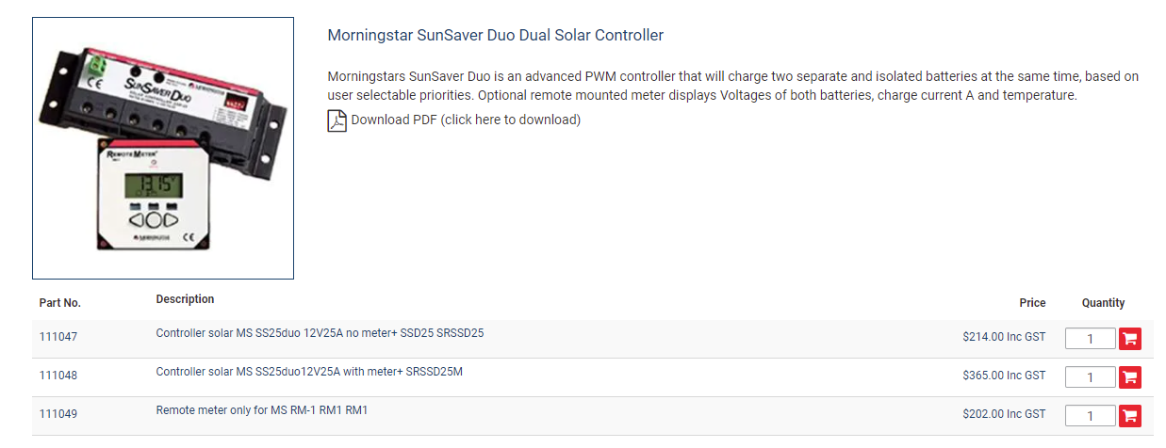
This is an Australian shop – so expect US prices to be about half.

